Project Design Phase-II
Technology Stack (Architecture & Stack)

Date | 30 JUNE 2026
Team ID | SWTID-2026-1795
Project Name | HEART DISEASE ANALYSIS
Maximum Marks

Technical Architecture:
The Deliverable shall include the architectural diagram as below and the information as per the table1 & table 2
Example: HEART DISEASE ANALYSIS
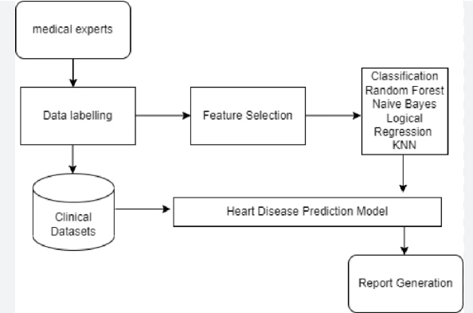
Table-1: Components & Technologies for Heart Disease Analysis
S.No | Component | Description | Technology
1. | User Interface | Clinical dashboard and reporting interface for cardiologists and healthcare administrators to monitor patient metrics. | Tableau Desktop, Tableau Cloud / Server, Web-embedded dashboard portals.
2. | Application Logic-1 | Core ETL pipeline to clean, join, and structure medical records (handling nulls, balancing data, formatting metrics). | Tableau Prep Builder / Python (Pandas).
3. | Application Logic-2 | Analytics extension gateway to pass live dashboard data into predictive pipelines. | TabPy (Tableau Python Server).
4. | Application Logic-3 | Automated natural language narrative generation to explain patient risk anomalies. | Tableau Pulse / Tableau Data Stories.
5. | Database | Structured local/on-premise storage for transactional electronic health records (EHR). | MySQL, PostgreSQL, etc.
6. | Cloud Database | Secure, highly scalable clinical data warehouse for aggregated heart disease research data. | Snowflake, Google BigQuery, or Amazon Redshift.
7. | File Storage | Storage for massive datasets, medical imaging metadata (DICOM logs), or historical CSV records. | AWS S3, Azure Blob Storage, or Local Filesystem.
8. | External API-1 | Real-time clinical lookup to dynamically fetch updated medical coding standards. | ICD-10/ICD-11 Medical Coding API.
9. | External API-2 | National or regional identity registration API to securely pull and verify patient demographics. | Aadhaar API (for India), or localized EHR Integration APIs (FHIR/HL7).
10. | Machine Learning Model | Risk prediction algorithm calculating the probability of cardiovascular disease based on clinical features. | Logistic Regression, Random Forest, or XGBoost model (deployed via TabPy).
11. | Infrastructure (Server / Cloud) | Environment hosting the data pipelines, calculation engines, and dashboard distribution access layers. | Local Configuration: Local Desktop client.  Cloud Server Configuration: AWS EC2, Tableau Cloud, Kubernetes (for TabPy/DB).

Table-2: Application Characteristics
S.No | Characteristics | Description | Technology
1. | Open-Source Frameworks | Core open-source libraries used for data handling, feature engineering, and hosting the live machine learning prediction engine. | Python (Pandas, NumPy), Scikit-Learn (for predictive modeling), TabPy framework.
2. | Security Implementations | Access controls and data protection mechanisms ensuring secure handling of sensitive patient health records. | AES-256 encryption (at rest/transit), Row-Level Security (RLS) in Tableau, HIPAA/GDPR compliance controls, Active Directory/SAML SSO.
3. | Scalable Architecture | Decoupled 3-tier presentation, processing, and storage architecture allowing independent scaling of analytical compute and databases. | Cloud-native analytics architecture using Tableau Cloud/Server, Snowflake data warehouse, and auto-scaling TabPy environments.
4. | Availability | Failover planning and workload management to guarantee clinicians uninterrupted access to critical cardiology data. | High Availability (HA) Tableau Server cluster deployments, multi-region database replication, AWS Elastic Load Balancing (ELB).
5. | Performance | Infrastructure optimization ensuring low-latency dashboard interactions when processing millions of historical patient data rows. | Tableau Hyper In-Memory Data Extracts, pre-aggregated database views, query caching, materialized views in Snowflake.

